ASSIGNMENT 10
Student Course Enrollment Manager
Unit 6 – Collections Framework in Java
Student Name | Sasanka Sekhar Kundu
Student | Sasanka Sekhar Kundu

1. Objective
To develop a Student Course Enrollment Manager using Java Collections Framework concepts. The program maintains confirmed students in an ArrayList and students waiting for a seat in a LinkedList. It provides menu-driven operations to add, display, search, promote, remove, and manage students.
2. Problem Statement
The application should allow a user to manage student course enrollment through a repeated menu. Confirmed students are stored in an ArrayList<String>, while students waiting for enrollment are stored in a LinkedList<String>. The program demonstrates collection operations, iteration, searching, exception handling, Scanner input, and switch-based menu control.
3. Concepts Used
Java Concept | Purpose
ArrayList<String> | Stores the enrolled/confirmed student names.
LinkedList<String> | Stores the waiting queue and supports insertion/removal at the ends.
List Interface | Provides the collection abstraction implemented by ArrayList and LinkedList.
add() | Adds a student to the enrollment list.
addLast() | Adds a student to the end of the waiting queue.
removeFirst() | Removes the first waiting student for promotion.
remove() | Removes a selected student from the enrollment list.
indexOf() / contains() | Searches for a student and identifies the student's index.
for-each / iteration | Displays the contents of the collections.
size() | Reports the number of enrolled and waiting students.
Exception Handling | Handles invalid or empty collection operations safely.
Scanner | Accepts menu choices and student names from the user.
4. Menu Operations
- 1. Add Student to Enrollment List
- 2. Display Enrolled Students
- 3. Add Student to Waiting Queue
- 4. Promote Student from Queue
- 5. Search Student in Enrollment List
- 6. Remove Student from Enrollment List
- 7. Display Waiting Queue
- 8. Exit
5. Program Working
- The program starts by creating an ArrayList named enrolledStudents and a LinkedList named waitingQueue.
- A loop repeatedly displays the Student Course Enrollment Manager menu until the user selects Exit.
- Option 1 accepts a student name and adds it to enrolledStudents using add().
- Option 2 traverses enrolledStudents and displays all enrolled students.
- Option 3 accepts a student name and adds it to waitingQueue using addLast().
- Option 4 removes the first student from waitingQueue using removeFirst() and adds that student to enrolledStudents.
- Option 5 searches the enrollment list using contains() and indexOf() and reports the student's index.
- Option 6 removes a selected student using ArrayList.remove().
- Option 7 displays all students currently waiting in the queue.
- Option 8 terminates the application.
6. Exception Handling
The program uses try-catch blocks to prevent invalid collection operations from terminating the application. NoSuchElementException can occur when removeFirst() is attempted on an empty LinkedList, while IndexOutOfBoundsException is handled for invalid index-based operations. Meaningful error messages are displayed.
7. Output / Execution Evidence
The submitted execution screenshot shows the program running successfully in the terminal. The Student Course Enrollment Manager menu is displayed, a student is added to the enrollment list, and the enrolled-student display option is executed.
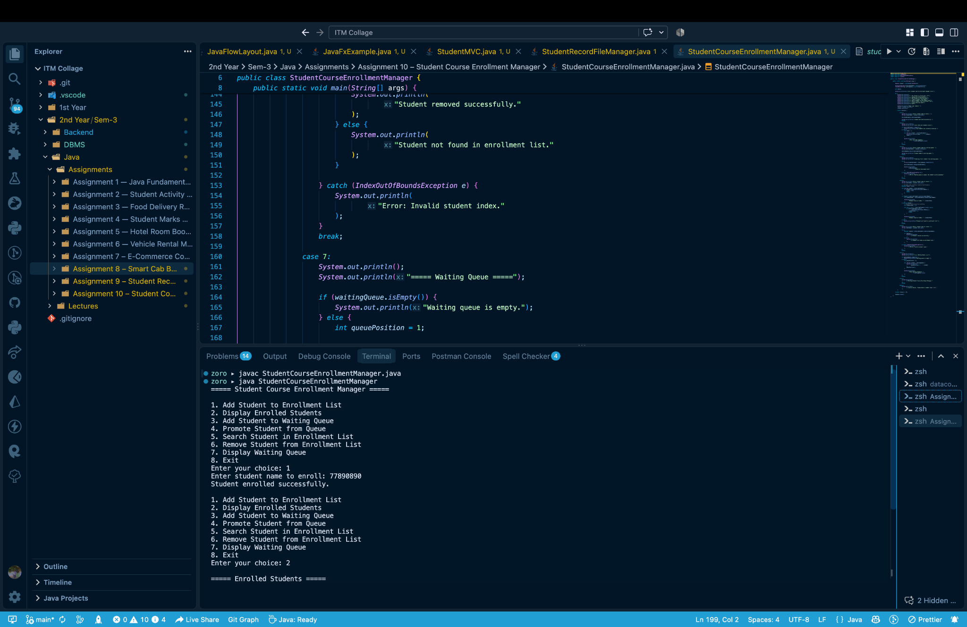
Figure 1: Student Course Enrollment Manager – Program execution screenshot
8. Requirement Verification
Requirement | Implementation | Status
ArrayList<String> | Implemented for enrolled students. | Yes
LinkedList<String> | Implemented for waiting students. | Yes
add() | Used to enroll students. | Yes
addLast() | Used to add students to the waiting queue. | Yes
removeFirst() | Used to promote the first waiting student. | Yes
remove() | Used to remove an enrolled student. | Yes
indexOf() / contains() | Used for student searching. | Yes
for-each / Iterator | Used to traverse and display collections. | Yes
Exception handling | Handles invalid/empty collection operations. | Yes
Loop + switch | Controls the repeated menu. | Yes
Scanner | Accepts user input. | Yes
9. Result
The Student Course Enrollment Manager was implemented successfully using ArrayList and LinkedList. The program demonstrates enrollment management, waiting-queue promotion, searching, removal, iteration, menu-driven control, Scanner input, and exception handling as required.
10. Conclusion
This assignment demonstrates practical use of Java's Collections Framework. ArrayList is used for the enrollment list, while LinkedList models the waiting queue. The program also demonstrates common collection methods, iteration, searching, exception handling, and structured menu-based programming.

